**Impact of COVID-19 on the Multi-Platform Video Game Genres**

**Abstract**

This report investigates the influence of the pandemic on the video game genres from 2018 to 2023, through the range of multi-platform gaming accessibility: Mobile, PC, and Console. Acquisition of data is performed through the iTunes API, Web scraping of AppStore Charts, and outside websites manual scraping, in order to construct data frames for organised analysis of industry trends. Inferential statistics are applied though analysis of visual models of aggregated data. The purpose of this report is to uncover the COVID-19 impact on user interest in video game genres.

**Introduction**

Video games are an accessible method of escapism, entertainment, and community construction;

that can be accessed at home, work, and even on the go. Through the lens of the gaming world, we can reflect on broader social trends, as the industry is constructed based on user experience and wish-fulfilment of the digital landscape. As people spent far more time at home in 2020-2021, instead of interacting with the outside world, the focus of their digital interests shifted. Thus, we hypothesise that due to accessibility of video games as at-home entertainment, there has been a surge in their consumption;evident by the change in mass-interest towards various genres. The study aims to analyse the evolution of popularity trends of video game genres from pre-lockdown (2018-2019), lockdown (2020-2021), to post-lockdown (2022-2023) time periods. Genres are subset through the trickle down model from most accessible**¹** (Mobile gaming) to least accessible (Console) platforms, in order to narrow, and draw comparisons between Mobile, PC, and Console gaming. Focus of PC gaming demonstrates intersectionality of the humanitarian and marketing interests in genres of : Action, Horror, Adventure, Simulation, Shooter, and Puzzle (as subset from Mobile gaming industry).Analysis of the least accessible gaming method (Consoles) is demonstrated through the lens of the established multi-platform genre narration and user expectations. The research focuses on the following questions:

* What genres have maintained popularity though 2018-2023 across platforms?
* Which genres demonstrate niche interest as per platform’s accessibility level?
* What are the outliers in genres that demonstrate insight into COVID-19 trends?
* As a proxy for game popularity, how has the number of user ratings changed across different genres from 2018 to 2023?
* What patterns emerge in the release of video games during the pandemic years, and how do they compare to pre and post-pandemic levels?

**Mobile gaming - Mariia Omelchak**

As the most popular mode of gaming, we decided to start our data acquisition and analysis with IOS Gaming specifically, as we are centering this research paper on North American gaming audience and COVID-19 experience. Setting out to gather free user data, such as downloads and current/historic users on the apps was impossible due to Apple’s tight user-non disclosure agreement**²**. As the most popular method of modern gaming, mobile games set the genre standard for the preceding consoles.

**Data Acquisition and Processing**

For this project, I scraped 6 websites manually in order to extract them into the Pandas data table, and create a dynamic plot of 2018-2023 genre evolution. There is no free documentation for the App Store interface, that does not require a subscription or Statista.com data purchase, thus I used Lectures 9,10, and 14 in order to extract the data. The websites**³** used include historic documentation of charts in the following year, except for 2018 and 2023. For these two years I had to scrape an outside website**⁴** (dated in 2018, as the chart), as well as the current App store chart**⁵**. Packages that I used in order to parse through the sites and return them into an html are BeautifulSoup and requests. I used BeautifulSoup’s find_all() method in order to loop the request and extract the charts’ information for my use. Furthermore, processing and cleaning up data required me to use Pandas. The biggest challenge for me was to get a google driver to work, which it did not do even after days of trying, thus I did cross-input the genres and company names into the datatable. The variables of the final table that I used for visualisation were:

* Game : name of each game of the chart
* Year: 2018-2023
* Price: either free or paid
* Genre: the game genre that will be subset to to least-accessible gaming later on
* Company: that produced the game

There were 240 games total in the table, with repeating titles, such as Minecraft, or Five Nights at Freddy’s. The reasonable size of the samples allowed to create a ratio of games per year in a certain genre/ games that year overall, which resulted in a ratio that depicts popularity of genres in every year. My code is linked in the GitHub repository for replication and further details of the scraping process.

**Visualisation:**

I used Matplotlib and Seaborn for plot construction and formatting, and Imageio to render each plot into a png. I wanted to demonstrate the dynamic evolution of the video game genres by combining plots into a gif. The three plots represent Free, Paid and Free+Paid games, and their direct visual comparison through the frame change of the gif, which I slowed down just enough to be able to read the plot fully.





**Results:** The main goal of the mobile gaming analysis was to determine the top genres for less-accessible platforms. With purely inferential analysis of the 18 plots, we can see that Action at both price points is the dominant genre, along with Simulation, Board, Strategy and Puzzles. Most prominent breakdowns of the broad genre of action are: Horror (FNAF) and Shooters (COD). Another interesting observation is the popularity of Paid Board games during the quarantine period, maxing out at 20% of the overall popular paid games that year, which became a minor genre post-pandemic, at 5% in the same category. Another genre of Family games first appeared in 2020 (the beginning of COVID-19) and is still prominent today, with 6% of the 2023 popular all price games. As far as the free games market, Action games are consistently the top genre, except for 2019, when that genre was dominated by Casual games, that nowadays are not even grossing in the top genres of free games. The largest shift of the genres from pre-pandemic, to post-pandemic worlds is the increase in logical games, such as Word, Puzzle, Strategy games, which were previously replaced by Sports, Casual and Adventure games. We find it interesting that though COVID-19, people started to reach out to more intellectually stimulating mobile games, rather than purely entertaining ones. It is also evident that even apart from one another, people continued to play board games and create online connections though multiplayer Action games. This confirms out initial statement of video games serving as a method for social interactions and escapism for individuals in lockdown, that they expressed through engagement with Action ,Simulation, Puzzle, Horror, Shooting, and Strategy games.

**PC gaming - Yucheng Zhao**

For PC gaming, I sourced the data from the iTunes API, which provides access to a comprehensive database of video game data. The search was conducted focusing on the six major genres, inferred from Mobile gaming. The API parameters were selected to retrieve 200 games per genre, which is the maximum number that the API allows, ensuring a broad data representation. The search parameters include the search term, media type, entity, attribute filter, and country. I set a 1-second sleep between API calls to avoid hitting the rate limit. The data was filtered only to include the games released from 2018 to 2023 and sorted by the number of user ratings to gauge popularity.

**Visualisation**

I developed 2 primary visualisations:

* A scatter plot is created using ‘matplotlib’ illustrating the distribution of user ratings by release year and genre, highlighting trends and deviations.
* A line graph illustrating the number of user ratings per genre per year, offering a clearer picture of genre popularity over time.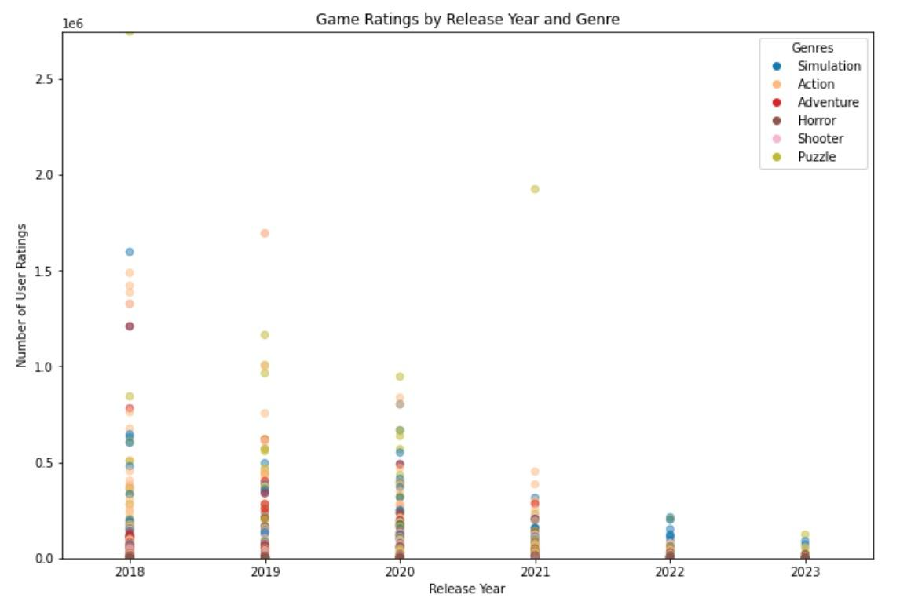

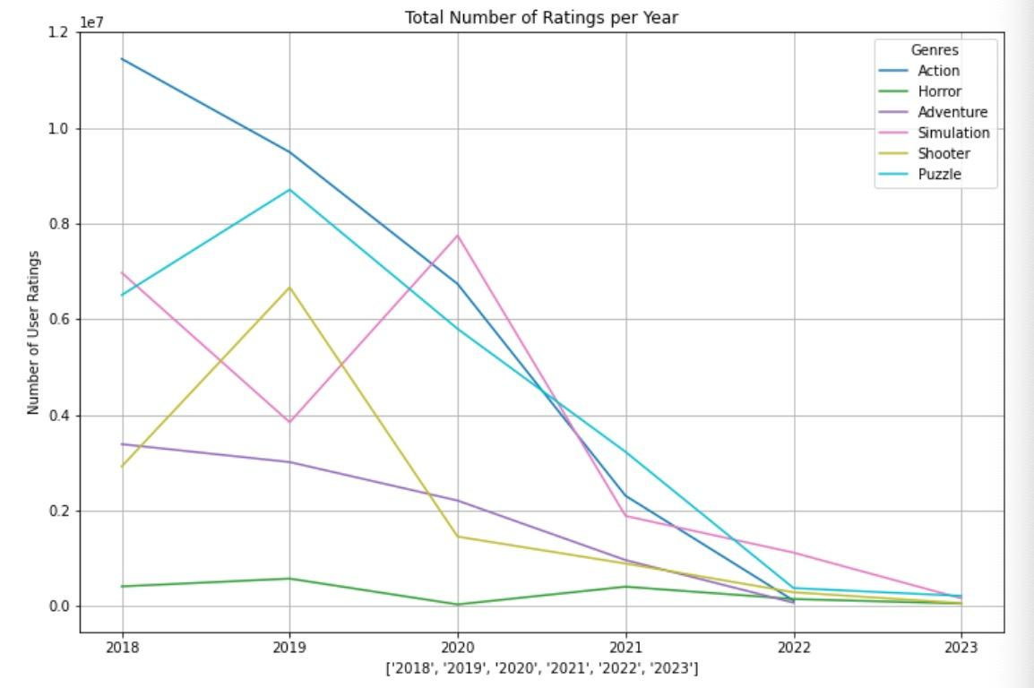

**Results**

**Distribution:** From the scatter plot, we observed a noticeable concentration of data points in the year before 2020. This indicates a higher number of game releases in the pre-pandemic year, or the games have had more time to accumulate user ratings. The years 2020 and 2021 show a lesser density of games with higher user ratings compared to 2018 and 2019, which might suggest an impact of the pandemic on game development or a shift in user rating behaviour.

**Trends:** The vertical spread of points in each year suggests a variety in the number of user ratings. A few outliers have very high numbers of ratings, while the majority have significantly lower. It suggests that the video game market is hit-driven, where a few games capture the most user attention. From the line graph, each genre has a unique trend being displayed. Some genres showed a peak in one year followed by a decline, while others displayed a steadier trend. The plot shows that certain genres, such as Action and Puzzle, consistently have games with higher numbers of ratings across the years, indicating a sustaining popularity for these genres.

**Impact of the Pandemic:** The years of 2020 and 2021 seem to show more fluctuations. For example, the simulation genre peaked in 2020, possibly due to an increase in engagement during the early stages of the pandemic. Its following decline in 2021 could suggest a normalisation as people adjusted to the new living style and got used to the pandemic circumstances. I also noticed that the Action genre appears to have had a negative spike in popularity during the pandemic years from 2020 to 2021 which could possibly suggest a decline in popularity for the Action genre during the pandemic. However, it is also possible that users’ willingness to rate games is affected by the pandemic. The data from 2022 and 2023 is relatively sparse compared to that of the previous years, which could either indicate the dataset is incomplete or fewer games have been released.

**Console Gaming** - **Zhiye Jiang**

In the area of console gaming, we face significant limitations in accessing data. Most websites that offer annual or quarterly data are not free, and accessing this information often requires direct contact with gaming companies. However, we do have access to VGChartz[1], a resource that offers a wide range of game statistics, including console, publisher, VGChartz score, critic score, user score, total units shipped, release date, and the date of the latest update. This data covers the period from the game's release to the present, but it does not provide details for each specific time period were interested in. Still, reviewing the overall sales numbers can be insightful, especially for understanding the trends in the five game genres we are studying, except for the horror genre, as this data is absent on the website.

Thanks to a reference from GregorUT[2], we've managed to get our hands on a CSV file that contains all the necessary data extracted from VGChartz. This file is quite detailed and includes various key metrics:

* Rank: Positions of games based on overall sales.
* Name: Titles of the games.
* Platform: The gaming platforms (like PC, PS4, etc.).
* Year: Release years of the games.
* Genre: Categories of the games.
* Publisher: Companies that released the games.
* NA_Sales: Sales figures in North America (in millions).
* EU_Sales: Sales in Europe (in millions).
* JP_Sales: Sales in Japan (in millions).
* Other_Sales: Sales in other parts of the world (in millions).
* Global_Sales: Total sales globally.

With this file, we can now import it into Python and convert it into a Pandas DataFrame, which will allow us to sort the data into five game genres: Action, Adventure, Simulation, Shooter, and Puzzle. Extract the top five global sales in each genre and visualise it using matplotlib.pyplot.

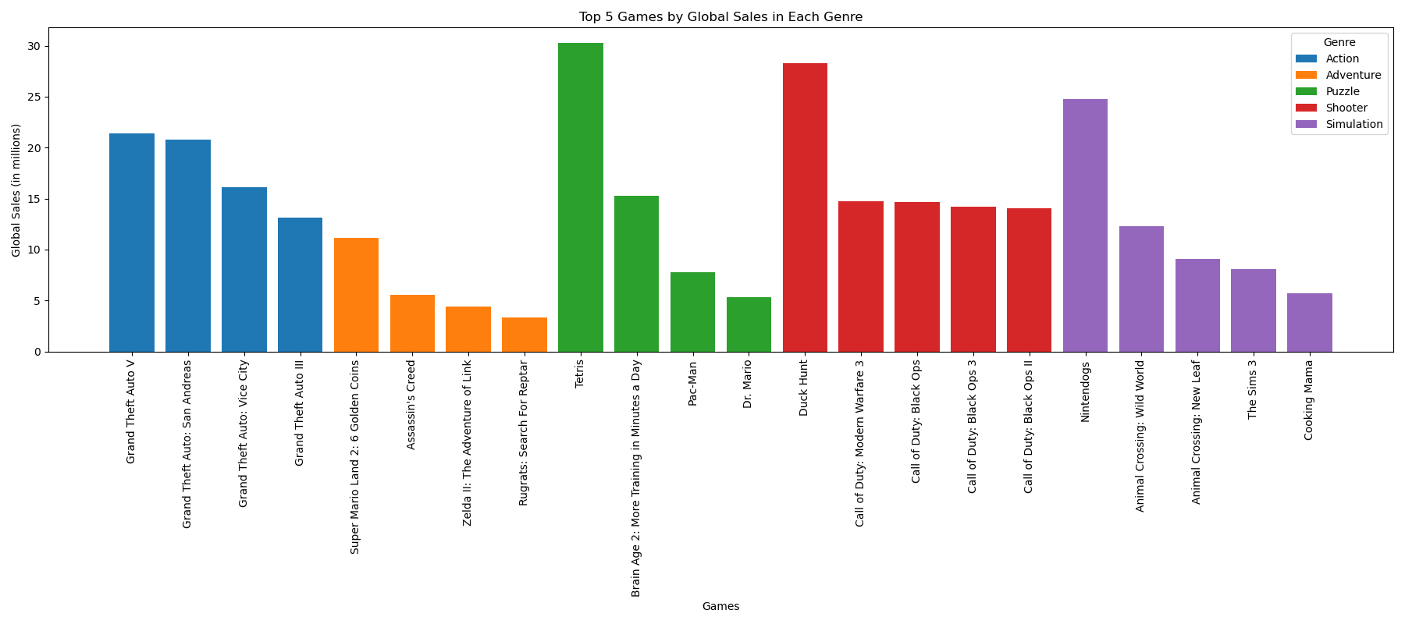

In observing the bar graph above, it becomes apparent that the Action genre, in blue, consistently exhibits high sales figures. In such cases, to further analyse this trend, we managed to procure Sony’s earnings release spanning from 2018 to 2023. These documents, which detailed PlayStation action game sales during such period, are available in PDF format on Sony’s official website[3]. Due to our limited expertise in extracting tables from PDF files, we manually converted this data into a Pandas DataFrame and subsequently exported it as a CSV file for easier manipulation and analysis.

Again utilising matplotlib.pyplot function, the Cumulative Sell-Through Units Over Time for Sony Games are presented below:

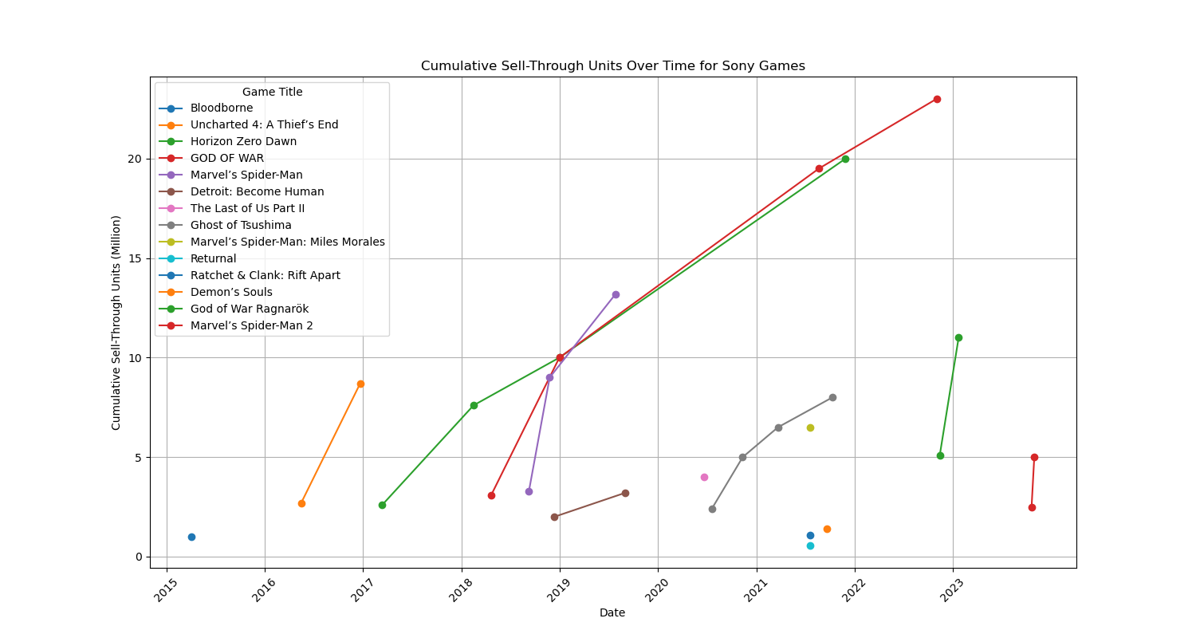

The x-axis represents the time, with January 1st from 2018 to 2023 labelled for spacing purposes. The y represents the cumulative sell-through unit in millions. With each colour representing different action games, we observed a significant increase in sales for “God of War” and “Horizon Zero Dawn”. Other games like “Marvel’s Spider-Man” and “Ghost of Tsushima” have notable increases as well. One reason might be that they were released just before COVID-19 and remain popular in COVID. On the Contrary, The post-COVID games such as “Uncharted 4: A Theoef’s End” and “Bloodborne” (released in 2015 but shown in the 2018 report) do not experience any increase in COVID.

Upon examining the cumulative sales data for Sony's Action games from 2015 to 2023, it can be inferred that the pandemic might have influenced sales figures for action games, particularly when comparing pre-COVID periods. One inference might be that the game released before COVID remains popular and became gamers’ first purchase priority. Nonetheless, given the limitation of the sample size and the potential incompleteness of the data provided in the company's releases, it would be imprudent to definitively validate this hypothesis based solely on the available information, and one’s further investigation is hindered.

**Conclusion:**

The project encountered several challenges that shaped the methodology and interpretation of the results. Firstly, the iTunes API and the AppStore do not contain historical data, which necessitated the use of game releasing dates as a proxy for differentiating the timeframe. Upon researching this subject we discovered that this is Apple’s approach to prevention on non-associate partners of the company to aggregate and sell user data and statistics. Additionally, the data lacks direct sales or user download data, so we must use user ratings as an indirect measure of game popularity. These challenges required a more careful approach to our analysis in order to keep our results robust, allowing us to observe changes on a macro level, instead of a detailed breakdown of each component. Since the lack of access to user data was a huge hurdle along the way, our team was still able to extract inferences about the intersectionality of game genre trend and COVID-19.

The most popular genre by far in the multi-platform study has consistently been Action, specifically titles that have been released period to pandemic, which possibly due to the rapid news cycle of 2020 have stuck to the collective consciousness more than the COVID releases. Another major area of pandemic-era gaming has become logical games, such as Puzzles, Strategy, and Board games, which allowed gamers to stay intellectually stimulated within the four walls of their house. Also during quarantine, users of computer platforms have rapidly decreased their reviews rate, which has been on the steady decline post-pandemic as well. A similar decrease in interest towards engagement with new/popular releases has been recorded in console gaming, where the lifetime of games, and public interest has been on the decline in the post-pandemic period. Perhaps all of the logical puzzles that we consumed were not enough to rescue our attention spans.

**Work Cited**

**¹** daboul, samer. “The Rise of Mobile Gaming: A Look at the Growing Industry.” *LinkedIn*, 10

March 2023, https://www.linkedin.com/pulse/rise-mobile-gaming-look-growing-industry-axel-vega. Accessed 15 December 2023.

**²** “App Privacy Details - App Store.” *Apple Developer*,

https://developer.apple.com/app-store/app-privacy-details/. Accessed 15 December 2023.

**³** Sites Scareped for Mobile Apps:

“Get the Top Games of 2019 : App Store Story.” *App Store*, https://apps.apple.com/story/id1484100878/. Accessed 15 December 2023.

“Get the Top Games of 2020 : App Store Story.” *App Store*, https://apps.apple.com/us/story/id1535572612. Accessed 15 December 2023.

“Get the Top Games of 2021 : App Store Story.” *App Store*, https://apps.apple.com/story/id1594410402/. Accessed 15 December 2023.

“Get the Top Games of 2022 : App Store Story.” *App Store*, https://apps.apple.com/us/story/id1653509564. Accessed 15 December 2023.

**⁴** “Apple announces its ‘Best of 2018’ lists across apps, games, music, podcasts and more.”

TechCrunch, 3 December 2018, https://techcrunch.com/2018/12/03/apple-announces-its-best-of-2018-lists-across-apps-games-music-podcasts-and-more/. Accessed 15 December 2023.

**⁵** “Top iPhone Casual games on the App Store - Apple.” App Store,

https://apps.apple.com/us/charts/iphone/casual-games/7003. Accessed 15 December 2023.

“Fy 2023” Sony, Supplemental Information, page 10

https://www.sony.com/en/SonyInfo/IR/library/presen/er/pdf/23q4_supplement.pdf

“Game Search” VGChartz,

https://www.vgchartz.com/gamedb/

“Video Game Sales”, GREGORYSMITH

https://www.kaggle.com/datasets/gregorut/videogamesales

1. VGChartz website link: [Video Game Charts, Game Sales, Top Sellers, Game Data - VGChartz](http://www.vgchartz.com/gamedb/)
2. Github link: [https: //github.com/GregorUT/vgchartzScrape/blob/master/vgchartzfull.py](https://github.com/GregorUT/vgchartzScrape)
3. Link to Sony’s Webpage: <https://www.sony.com/en/SonyInfo/IR/library/presen/er/archive.html>